St. Patrick Middle School (6th-8th grade) Football Registration

Participant’s Name ____________________________________________________________________

Grade Entering in Fall 2021 ____________________

Address ____________________________________________________________ Date of birth _______________________

City _______________________________ State ___________ Zip ___________________

Parent/Legal Guardian’s Name _________________________________________________________________________

Home Phone ______________________ Cell Phone ____________________ Work Phone ____________________

Email Address _____________________________________________________________________________________________

IN CASE OF EMERGENCY

Contact # 1 Contact # 2

Name _____________________________________________________ Name _____________________________________________________

Address __________________________________________________ Address __________________________________________________

Home # ___________________________________________________ Home # ___________________________________________________

Cell # ______________________ Work # ____________________ Cell # _____________________ Work # _____________________

St. Patrick Football TOGETHER WE WILL!
2012 Regional Champions
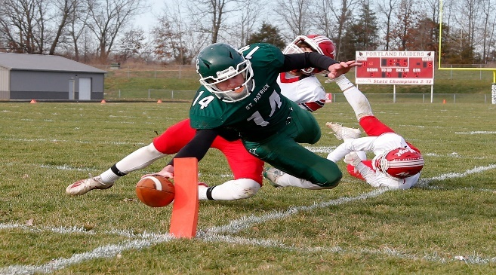
2014 CM8 Conference Champions
2016 CM8 Conference Champions
2017 Regional Champions, State Finalist
2018 Regional Champions
2019 Regional Champions, State Finalist
2020 Regional Champions, State Finalist

